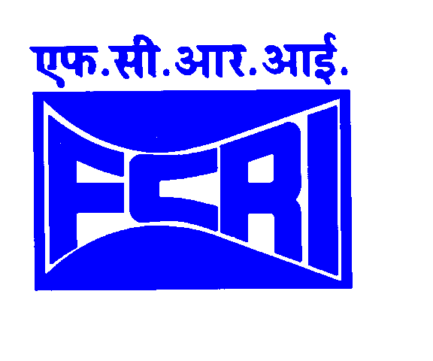 | FLUID CONTROL RESEARCH INSTITUTE  KANJIKODE WEST, PALAKKAD – 678 623, KERALA, INDIA  (Under Ministry of Heavy Industries & Public Enterprises - Govt. of India)  Phone: (91) 491-2566120/2566206 Fax: (91) 491-2566326  Email: purchase@fcriindia.com  Web: http://www.fcriindia.com

ADDENDUM TO TENDER NOTICE
PUR/FCRI/15250/PT/GPG/2015-16 Dated 23rd March 2016

Sub: Supply, installation & commissioning of Gas Piston Gauge.

Quantity – 1 No

The last date of receipt of Tender is extended from 21-03-2016 to 29-03-2016.
Sd/- DIRECTOR

FCRI is a premier Institute in South East Asia dedicated to Research & Development and Training in Fluid Flow Measurement & Control Techniques. The Institute serves as a National Certifying Authority and Quality/Reliability evaluation center for fluid flow, metrological, pressure, temperature, electrical parameters, noise, vibration etc. The Institute also provides consultancy services for petroleum, gas and water industries in flow related fields.

