**APPLICATION FORM for Short-Term Engagement**

Please paste

Your recent Passport Size

Photo here

**(Cleaning Staff Category)**

|  |  |  |
| --- | --- | --- |
| **S/N** | **Candidate Information** | |
| 1a | Name of candidate in full  (as per Class X Certificate) |  |
| 1b | Father’s Name in Full |  |
| 2 | Present Address (with PIN code) |  |
| 3 | Permanent Address (with PIN code) |  |
| 4a | Aadhaar Card Number |  |
| 4b | Attach copy of Aadhaar Card | Attached / Not Attached / Not Applicable |
| 5 | 1. Contact Phone number / mobile number 2. Whatsapp number |  |
| 6 | Sex | Male / Female / Others |
| 7 | Date of Birth | DD/MM/YYYY |
| 8a | Marital Status | Married / Unmarried |
| 8b | Name of Spouse in Full (if married) |  |
| 9 | State of Domicile |  |
| 10 | Nationality | INDIAN / Others (please mention) |
| 11 | Religion |  |
| 12a | Whether OBC? | YES / NO  OBC-Non-Creamy Layer / OBC-Creamy Layer |
| 12b | If OBC-Non-Creamy Layer, please attach copy of currently valid NCL Certificate (Central Govt.) | Attached / Not Attached / Not Applicable |
| 12c | Do you belong to /Scheduled Caste / Scheduled Tribe?  If YES, state whether SC / ST | YES / NO  SC / ST |
| 13 | Languages known |  |
| 14 | If you possess Driving Licence, please give details: Licence No. and date |  |
| 15 | Whether there are any criminal cases pending against you?  If YES, please provide Case details. | YES / NO |

|  |  |  |  |  |  |  |  |
| --- | --- | --- | --- | --- | --- | --- | --- |
| d | d | m | m | y | y | y | y |

16. Date when you can join duty if selected:

**Declaration**

I hereby certify that the particulars furnished in this Application are true, correct and complete in all respects. I agree and accept without reservation that if at any time, if any of the particulars provided by me is found to be untrue, incorrect and/or incomplete, my engagement at the institute will be terminated without notice.

I also understand that this application or engagement does not provide me any privilege or preferential rights for future employment at FCRI. That this Application is NOT for a Regular Post for present or future opening(s).

Place: Signature of Applicant

Date:



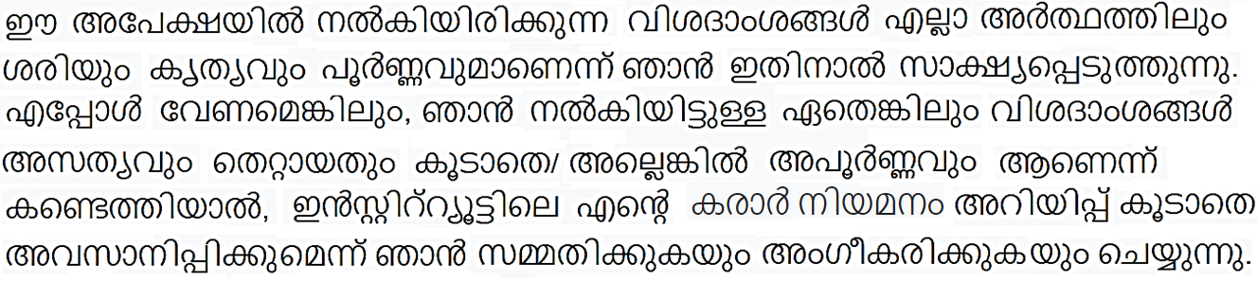

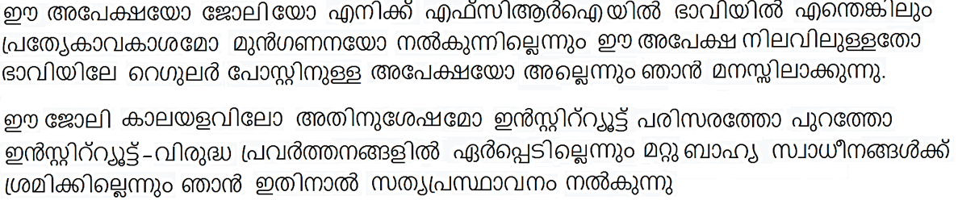

Place: Signature of Applicant

Date: